Guidelines for the Preparation of Extended Abstract or Paper (Times New Roman Bold 14 pt, style: Title)

First A. AUTHOR¹*, Second B. AUTHOR2 and Third C. AUTHOR3

¹Authors’ Department(if applicable), Organization, City, Country, author1@mail.com
²Authors’ Department, Organization, City, Country, author2@mail.com
³Authors’ Department, Organization, City, Country, author3@mail.com
*Contact: Corresponsing.Author@mail.com

Abstract
This is the template and instructions for extended abstracts. Authors are advised to read the extended abstract guidelines carefully and follow them strictly. All extended abstracts should be written in English. It should start with the paper’s title, author(s) name (s), authors’ affiliation, address and e-mail, followed by the keywords (up to six keywords) and the Abstract's text. The minimum number of words for the short abstract is 200 words (font size: 10point).

Keywords: One, Two, Three, Four, Five, Six (up to 6 keywords)

- Introduction

These instructions have been prepared to assist authors in the preparation of extended abstracts for reproduction in Conference proceedings to be provided to delegates. The conference proceedings will be produced as Online (NDT.net Open Access) and USB containing PDF versions of the extended abstracts. These guidelines are to ensure maximum uniformity of style and reproduction without further modifications - please try to follow them as closely as possible. An easy way to comply with the conference extended abstract formatting requirements is to use this document as a template and simply type your text into it or use the paste function. Length of the Extended Abstract should be minimum 2 pages including references. There is no limit in pages. The author can also submit in a full-length paper if they want. Please note that paper is for the conference proceedings (NOT for the SCIE journal submission)

- Principles and methods

The methodology must be clearly stated and described in sufficient detail or with sufficient references.

2.1 Format

The extended abstract should be written in MS Word. Use A4 page set-up and make all margins (top, bottom, left, right) 25 mm wide. The main text, like the extended abstract title used Times New Roman font, 14 point for the title and 12 point for the remainder of the extended abstract. Subheadings should be bold. Justify the body of the text both left and right. Do not include scientific symbols, acronyms, numbers, bullets or lists in the Extended abstract.
In preparing a manuscript, authors are solely responsible for the quality and appearance of the final product. If any questions or special problems arise, feel free to contact the conference secretariat at e-mail: conference@20thwcndt.com
2.1.1 Title
The title should emphasize the objective of the paper. Avoid excessive length. The title should be in 14 point bold, centered on the width of the opening. All words except for short connectives should have a capital initial.

2.1.2 Authors
Names of authors should be centered on the second line below the title. The name(s) should be shown as first name, middle initial, and last name or first initial, middle name, and last name, as preferred. Only the first letter of names should be capitalized.
2.1.3 Organization, Department
This section should be typed in 10 point. Authors' organization and Department should be separate line and leave a line gap below the name.

First A. AUTHOR^{1*}, Second B. AUTHOR² and Third C. AUTHOR³

¹Authors’ Department(if applicable), Organization, City, Country, author1@mail.com
²Authors’ Department, Organization, City, Country, author2@mail.com
³Authors’ Department, Organization, City, Country, author3@mail.com
*Contact: Corresponsing.Author@mail.com

Please include e-mail address for all authors. Departments, Affiliations, Cities and Countries should be translated in full into English.

2.1.4 Abstract
The abstract begins on the third line below the authors' names and addresses, as described above. The abstract should be typed in 10 point and its length in the range a minimum of 200 words. It should mention the techniques used without going into methodological detail and summarize the most important results. Please do not include any citations in the abstract. Avoid specialist abbreviations.

2.1.5 Keywords
Keywords should be written in the line below the abstract and should be in lower case (apart
from abbreviations or proper names). Keywords have to be separated by comma. Keywords
shall not include brand names. Keywords to be abbreviated should be given in full, followed
by the acronym or abbreviation in parentheses, e.g., time of flight diffraction (TOFD).

2.2 Tables, Images, Equations and Graphs

2.2.1 Tables, Images and Graphs
All the tables, equations, images and figures should be centered. Figures and images should be numbered, and figure headers should be placed under the figure or image; as for the tables, they should also be numbered, and the table header should be placed at the top. References (if any) of the tables, figures, and images should be presented right under the tables, figures and images in the form of author surname and publication date.
On figures showing graphs, both axes must be clearly labeled (including units if applicable). Please use only primary colors which contrast well both on screen and on a black-and-white hardcopy, as shown in Fig. 1

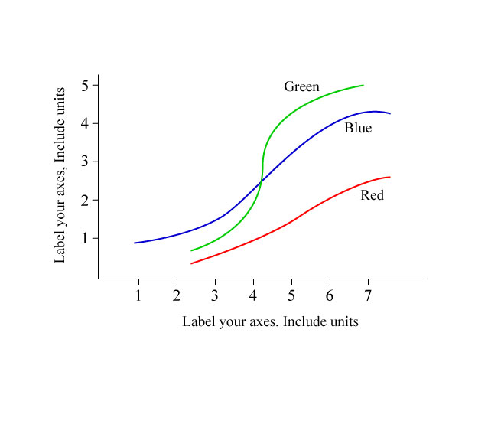
Fig. 1 A sample line graph using colors which contrast well both on screen
and on a black-and-white hardcopy

Graphics may be full color. Please prepare the figures in high resolution (300 dpi) for half-tone illustrations or images. Pictures must be sharp enough otherwise they will be rejected.
Tables should be designed to have a uniform style throughout the extended abstract, following the style shown in Table 1. Table captions should be in 10pt “Time News Roman” bold, centered, and the texts in Table should be set in 9pt “Time News Roman” font.

Table 1. Caption heading for a table should be placed at the top of the table and within table width.
(Use “time news roman” font, size 10pt, No spacing after table title)
 | A | B | C | D
A | Aa | Ab | Ac | Ad
B | Ba | Bb | Bc | Bd
C | Ca | Cb | Cc | Cd
D | Da | Db | Dc | Dd
E | Ea | Eb | Ec | Ed

2.2.2 Mathematics, Equations, Formulae and Symbols
Please type as much of the mathematical material as possible, with particular care in spacing and alignment, vertical as well as horizontal. Displayed equations or displayed chemical formulae (ie, those on their own line) should be in italics and centered with one line of space above and below. Equations should be labeled as in Equation (1) with a number towards the right margin, in case there is more than one equation

$a^{n}a^{m}=a^{n+m}$ (1)

3. Results and discussion

The findings and arguments of the work should be explicitly described and illustrated

- Conclusions

Conclusions should include (1) the principles and generalizations inferred from the results, (2) any exceptions to, or problems with these principles and generalizations, (3) theoretical and/or practical implications of the work, and (4) conclusions drawn and recommendations.

Acknowledgement
The heading of the Acknowledgment section and the References section must not be numbered. Number the reference items consecutively in square brackets (e.g. [1]). When referring to a reference item, please simply use the reference number, as in [2]. Do not use “Ref. [3]” or “Reference [3]” except at the beginning of a sentence, e.g. “Reference [3] shows …”. Multiple references are each numbered with separate brackets (e.g. [2], [3], [4]–[6]).

References

- Z. Mottl, "The quantitative relations between true and standard depth of penetration for air-cored probe coils in eddy current testing," NDT International, Vol. 23, No. 1, pp. 11-18 (1990)
- E. C. Guler, B. Sankur, E. Anarim, C. D. Mendi, O. Alkin, Y. P. Kahya and T. Engin, "Wavelet transform based transient detection," Advances in Signal Processing for Nondestructive Evaluation of Materials, Springer, Dordrecht, pp. 269-283 (1994)
- R. S. Chandel and S. R. Bala, "Effect of welding parameters and groove angle on the soundness of root beads deposited by the SAW process," Proceedings of Trends in Welding Research, Gatlinburg, Tennessee, USA, pp. 479-385 (1986)
- I. G. Kahn, Y. A. Bobrov, L. Y. Ignatov, E. Y. Shishkina, P. I. Lazarev, A. V. Kurbatov, "Dichroic Light Polarizers," U. S. Patent, 6049428 (2000)
- P. L. Burka, "A Hypertext History of Multi-User Dimensions," The MUDdex, <http://www.apocalypse.org/pub/u/lpb/ muddex/essay/> (5 Mar. 1998)

